**COMP 350 Optimisation**

**1506530**

1. **Monq**

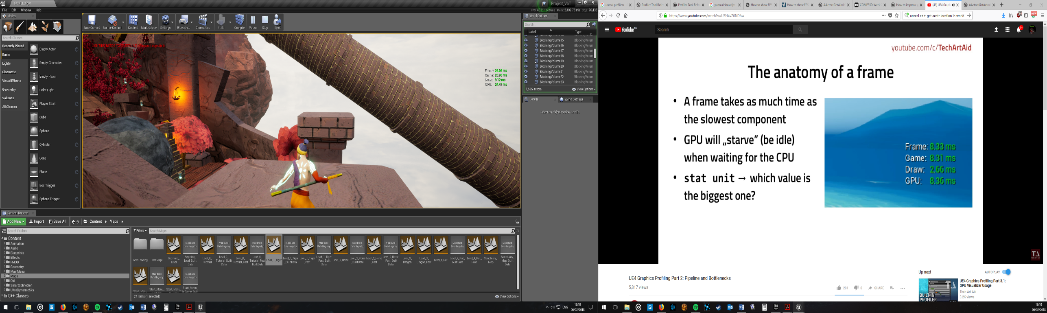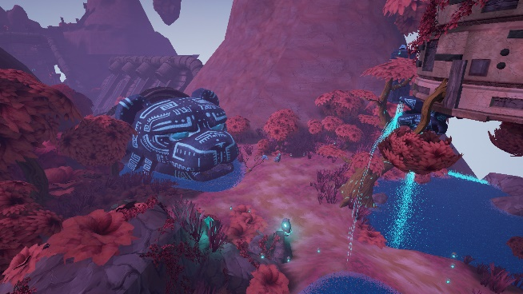 For comp 350 I propose optimising MONQ. This is a third person platformer puzzle game, which uses the Unreal engine. Monq was a second-year project for me but for the majority of the group it was a third-year project. Production for Monq began in the summer before my second year began, this involved producing design documents and learning a new engine. Unreal was chosen as it has C++ capabilities and the artists wanted to try something new. During the main development process of the game we didn’t take optimisation into consideration very much, this is evident from the overuse of particles and many instances of dynamic lighting. Due to this lack of consideration to optimisation, the game does run slowly. Recently I ported the game from 4.14 to 4.18 and this has improved a few issues there are still many left to fix.

Currently the game runs at ~45 fps on an I7 3770K with a GTX 780.

To begin with I need to find where the bottleneck is, from the picture to the left we can see that the Frame, Game and GPU are quite similar in number so the issue could be any one of them.

1.1 Tools:

• Unreal Profiler

• Unreal GPU Profiler

• Unreal Statistics Profiler

To find any issues with the CPU for this project I will be using the unreal in-editor profiler, this will tell me the current points where the CPU is slowing down.

From the initial use of the profiler in a development build, the issue seems to be the CPU waiting for tasks to complete, this leads me to believe that either the GPU or a code issue. As the GPU time is relatively close to the Game time then it is probably the game Code.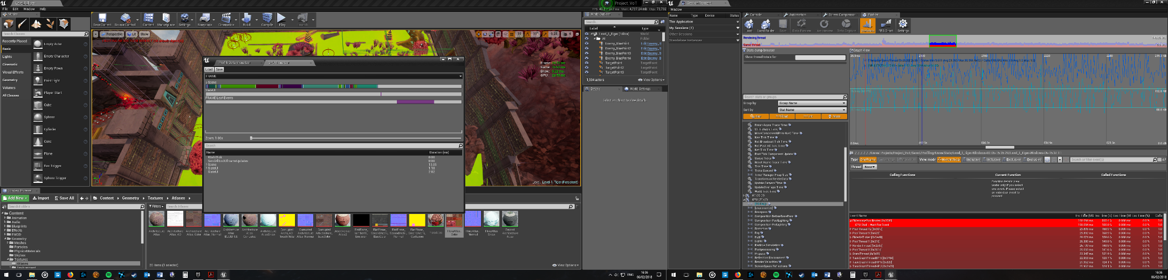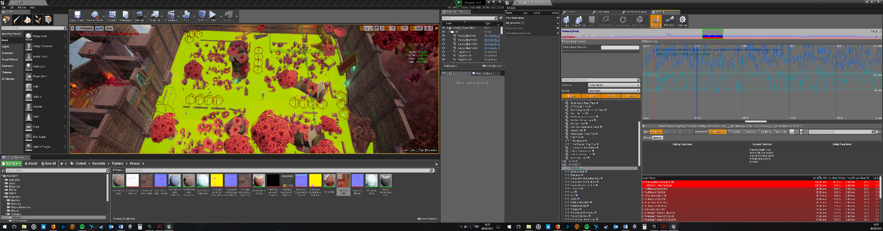

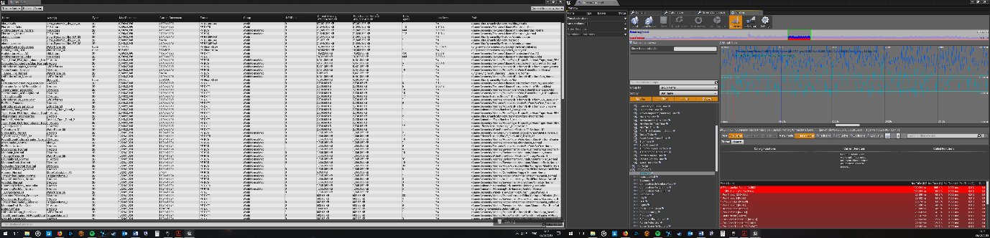 Two other tools that can be used are the GPU profiler and the statistics profiler right and left picture respectively. The Statistics profiler can be used to view the stats of every object used in the game including the textures used, you can see how large the original texture is and how large the texture is when used in-game. The GPU profiler can be used to see each TYPE of object that is rendered and its GPU cost.

After looking more closely at the profilers I could see that the issue wasn’t, in fact, the CPU but the GPU as can be seen in the next figures.

1. **Preliminary Optimisations**

After looking at the profilers I noticed that in the statistics panel several textures were being referenced in 4k by hundreds of actors. I went through each texture and reduces their resolution to between 1080p and 512. This improved the game's performance to some degree. As seen below, there is still a considerable issue with the GPU bottlenecking in areas of the game. The images on the left are from the initial profiling of the game and the images on the left are after reducing the texture sizes. Then in descending order, the areas of testing are:

1. The beginning of the Tiger Level

2. Midway through the Tiger Level

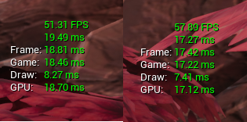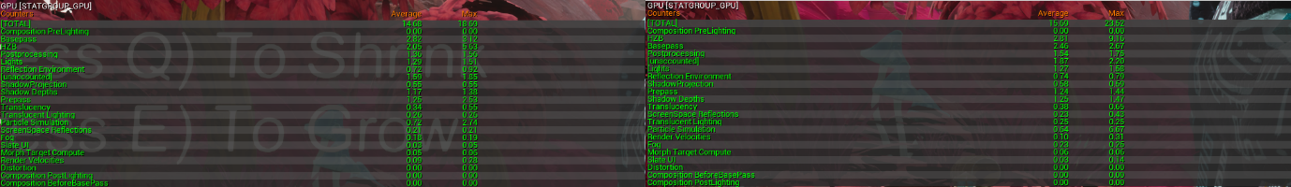3. Tutorial Level

From the GPU stats it is unclear at this point what exactly could be causing an issue, but as we can see the Game is almost matching the frame so there is also a bottleneck there too, so one step I will be taking is to use the profiler for the scripts at this point. Though running at 17-18ms is almost 60fps so not too much of a worry at this point.

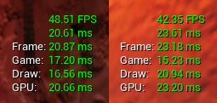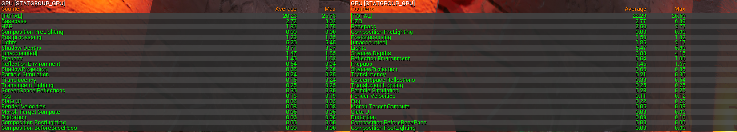Looking at the stats halfway through the level, reducing the textures obviously has not had any effect on the GPU but is most certainly clear the GPU is the issue, as the Game is far quicker with a 15-17ms speed than the GPU with 20-23ms speed. This bottleneck is limiting the game to less than 45fps which is no idea.

Looking at the GPU stats we can see that there is an obvious culprit here, the lighting, at 5+ms this is causing a big drain on the GPU cycles. Unfortunately, you can not get much more details from the in-game stats, but running the GPU profiler in the editor can give you a basic idea of what lighting is the cause of this issue. There is also the issue of shadow depths which is also related to lighting.

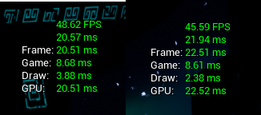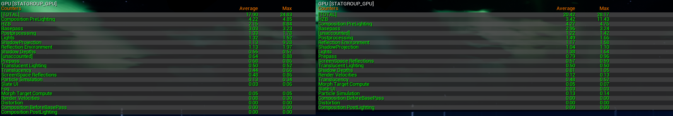In the tutorial level the GPU is also the issue, but looking at the GPU stats it is for a very different reason, as the lighting is down to 1.38ms instead of 5+. Here the issue is the Composition PreLighting, which is mostly affected by the Rendering resolution, and occlusion. This again is an issue with the lighting as this is a costly thing to render.

The next step that I shall be taking is to simplify the lighting as much as possible but ensuring that all lights that don’t move are set to static and attempting to reduce the amount of lighting used, although this could also include large actors that cast shadows.

1. **Optimising**
   1. **What to Ignore**

**HZB**

According to the discussion boards “on DX11 it’s is expected that CPU driver bubbles will manifest in a suspiciously large value on some section of a profile GPU. Not much we can do about it until we are on DX12.”

This means that the HZB will produce large values and there’s nothing I can do about it.

**BasePass**

BasePass is, according to a forum the drawing process of the in-game assets, so to reduce this number you would just have to have less polygons rendering in-game.

**3.2 Further Optimisations**

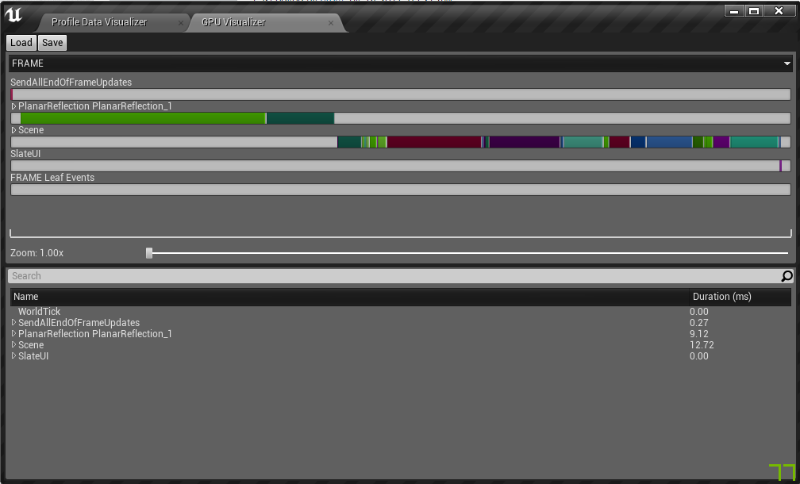 Changing lights as actuation radius was huge this helped a little but it wasn’t the main issue, as a lot of the lights were set to movable, so changing them to stationary or static helped more. Though from the results it did not provide enough of a boost to the framerate.

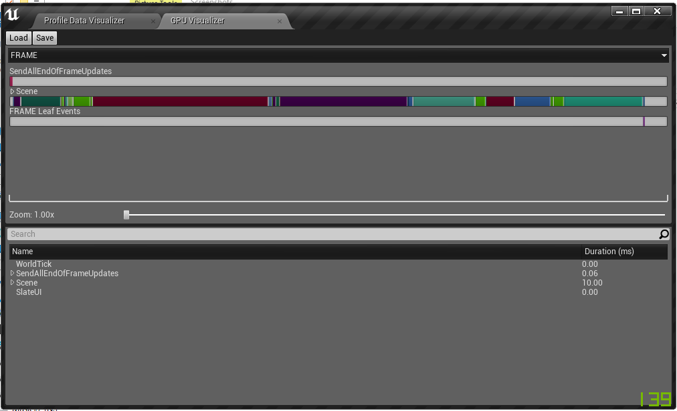 Here we can see a GPU breakdown for the tutorial level, as can be seen, there is a major issue with the planar reflections taking up 9ms of the rendering time. Having heavily detailed reflections in this scene wasn’t a priority so deleting the planar field was the best option and the following table was the result.

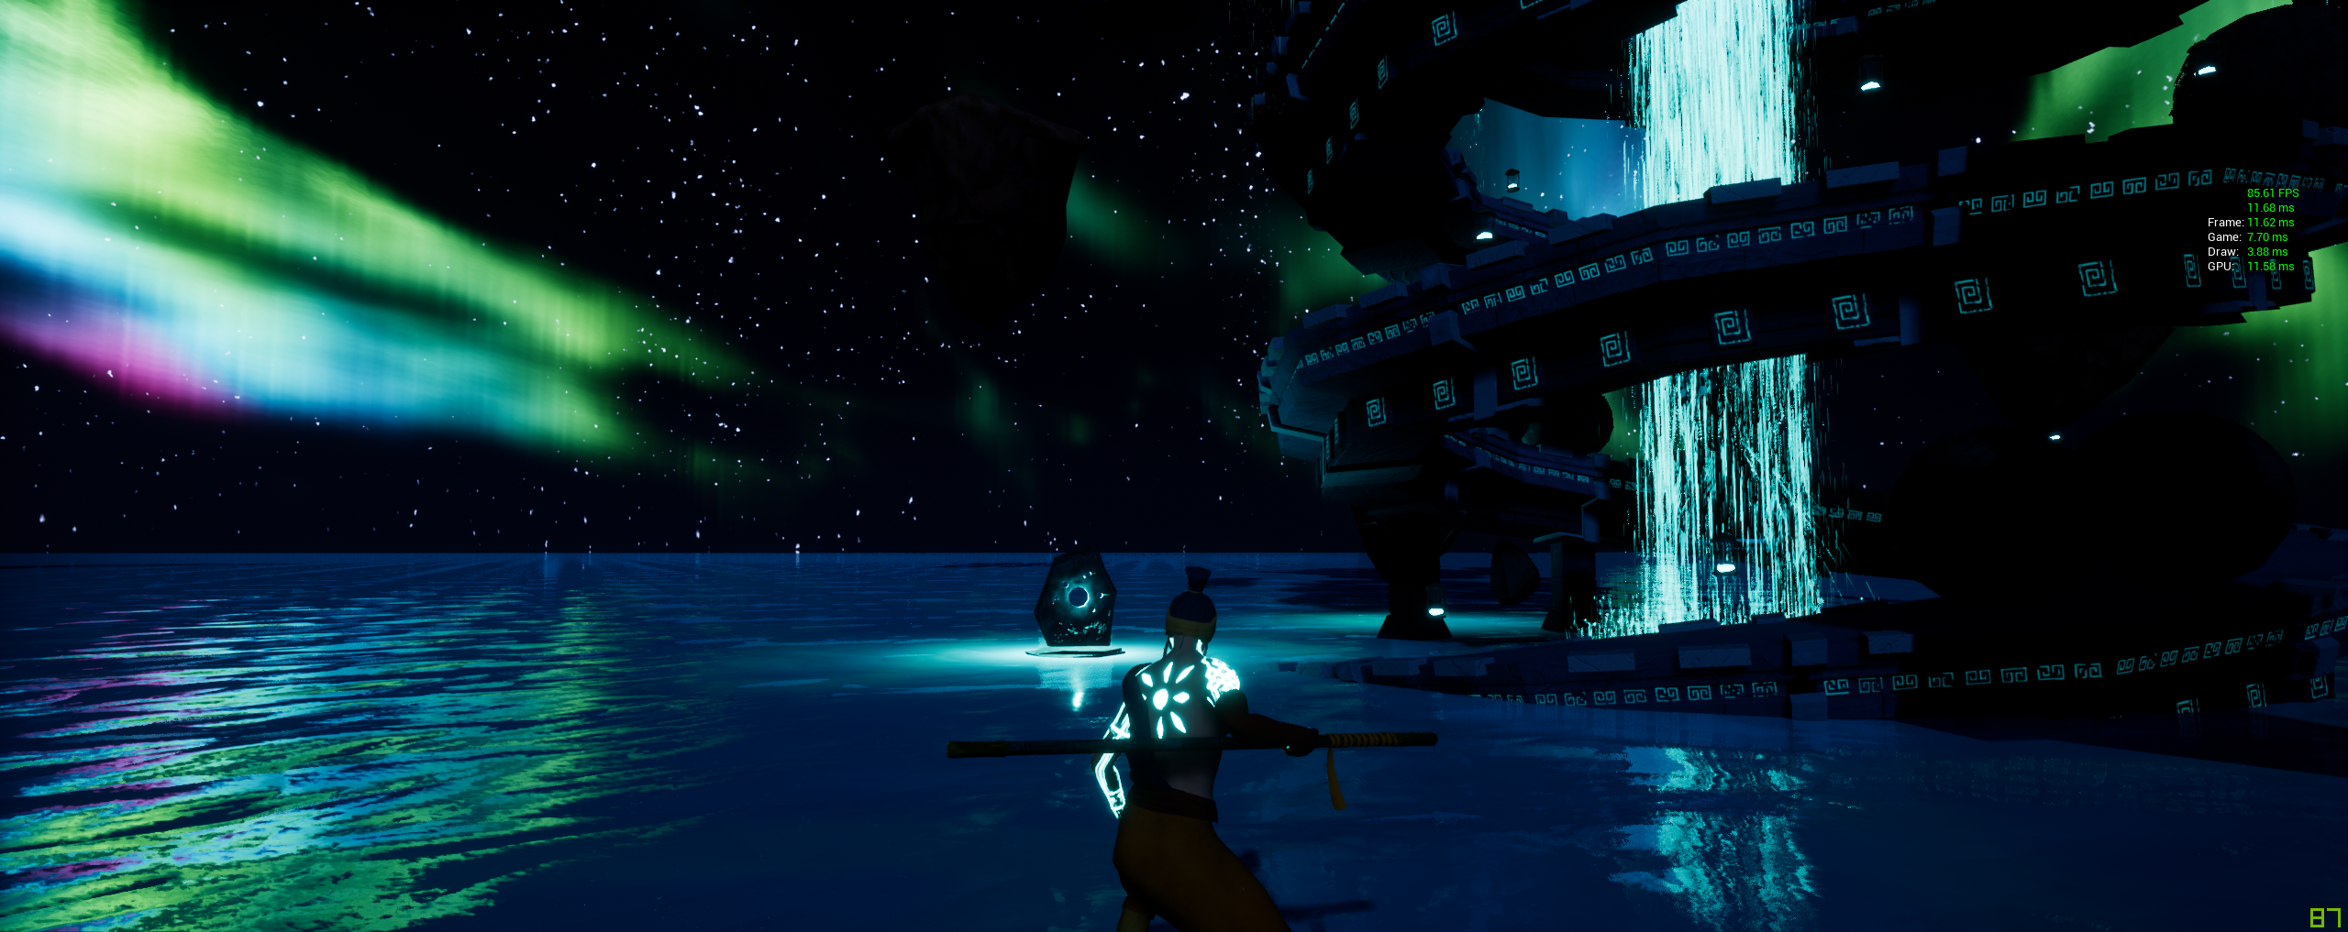This effectively doubled the framerate for this scene. Before (Left), After (Right).

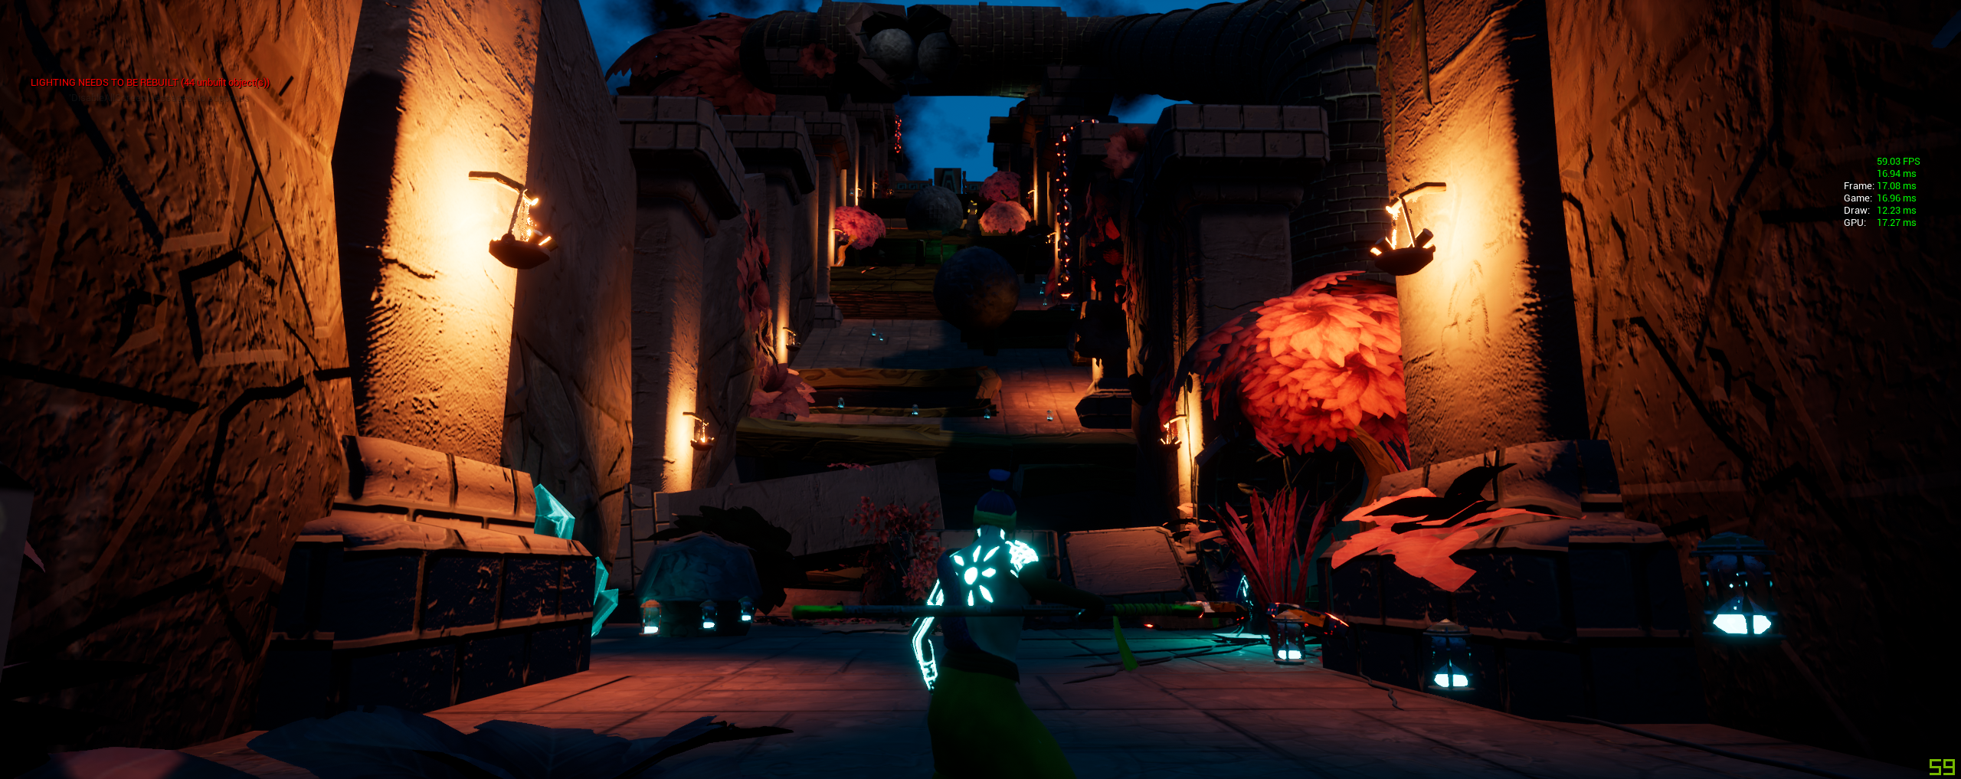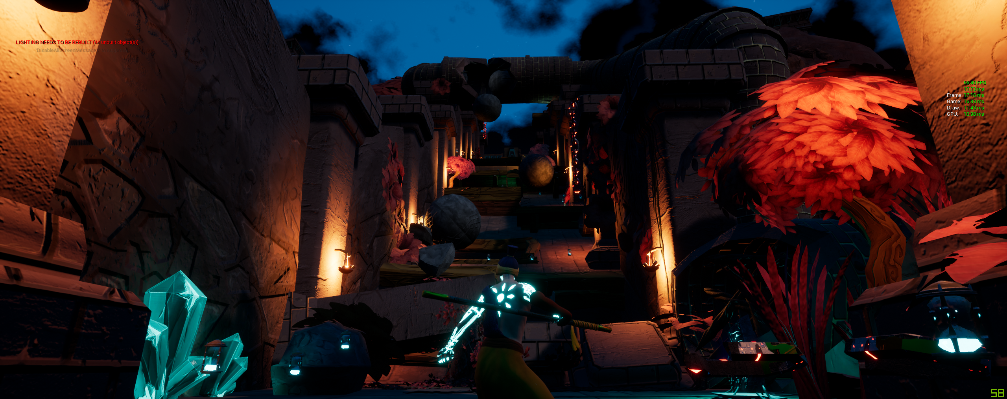The main challenge was to squeeze more frames out of the main level of the game, again changing the lights to static or stationary helped reduce the load on the GPU, but that wasn’t enough. I also removed shadows and collision from objects that were unreachable which improved the game by a few frames, as well as some of the larger objects were casting shadows but having no shadow would not affect gameplay so their shadows were disabled. Also from the first results post-processing was taking up some GPU power, but removing it had no effect on the game, as the GPU profiler as can be seen later shows that there is still a post-processing rendering on screen.

The results were as follows: (Left) Beginning (Right) Middle.

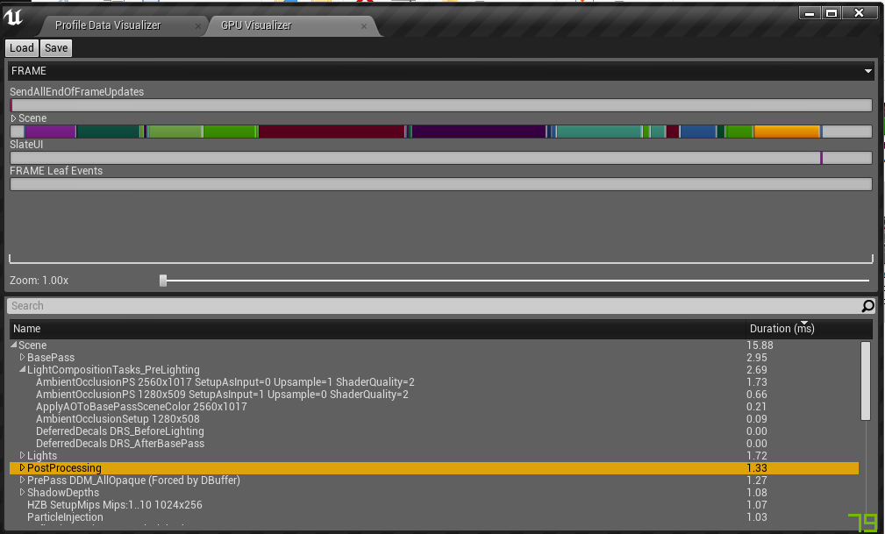Though the level did improve by 2 frames at the beginning and 10 frames at the end, I wasn’t happy. I looked into the issues a little further, the following GPU profiler shows the state of the game at this point.

This was taken at the beginning of the level, and as can be seen the profiler’s numbers are slightly off from the in-game stats, with the profiler showing 15.88ms and the in-game stats showing 17.27ms. This made me slightly dubious about the in-game stats as it has been stated that the engine tends to buff up the in-game ones and the GPU profiler can be trusted more.

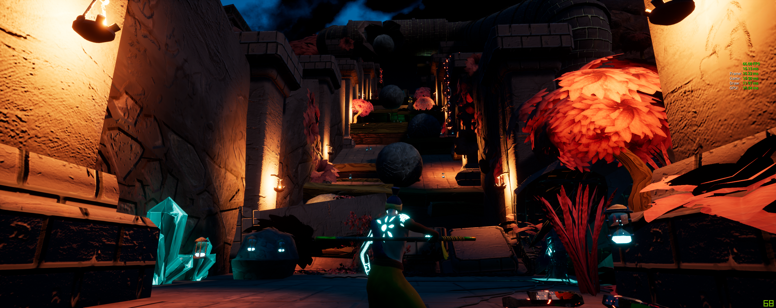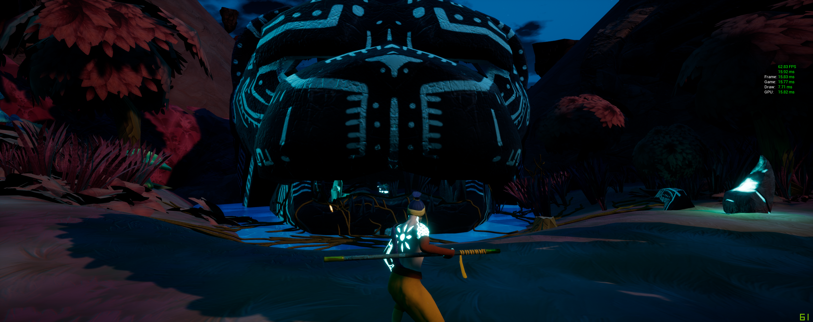Though the Post-processing confused me as there were no PP volumes in the level at this point, this made me look for any volumes in the game that were hidden(renamed). Doing this led to the discovery of many geometry volumes laid out across the level that weren’t deleted after the white boxing of the level. Unreal’s geometry editor is incredibly unoptimized and should only be used in prototypes and replaces asap. Though they were set to subtract they were still trying to have an effect on the world. Also in the process, I found a few more lights that could have been set to static. The results were are follows:

(Left) Beginning of level (Right) Middle of level.

As can be seen, the framerates have improved to over 60fps, which was the goal, though it is worth noting that the image on the left jumps from 58-62fps. This is an important reminder here is to make sure that old assets used in white boxing are always cleared and to ensure any lights that are for ambience only (not an obvious source like a lamp) should always be static.

Though I’m not sure if it made much of a difference optimisation wise reducing particle emissions and changing textures so the material deals with opacity seem to have made a small difference after changing it.